MLA0105 - Artificial Intelligence and Expert System for Gaming

EXPERIMENT- 1: SLIDING PUZZLE (3 X 3)

from collections import deque
def print_puzzle(state):
for i in range(0, 9, 3):
print(state[i:i+3])
print()
def get_next_states(state):
moves = []
idx = state.index(0) # empty space (0)
directions = {
0: [1, 3],
1: [0, 2, 4],
2: [1, 5],
3: [0, 4, 6],
4: [1, 3, 5, 7],
5: [2, 4, 8],
6: [3, 7],
7: [4, 6, 8],
8: [5, 7]
}

for d in directions[idx]:
new_state = state[:]
new_state[idx], new_state[d] = new_state[d], new_state[idx]
moves.append(new_state)
return moves
def solve_puzzle(start, goal):
queue = deque([start])
visited = set()
parent = {tuple(start): None}

while queue:
curr = queue.popleft()

if curr == goal:
path = []
while curr:
path.append(curr)
curr = parent[tuple(curr)]
return path[::-1]

visited.add(tuple(curr))

for nxt in get_next_states(curr):
if tuple(nxt) not in visited:
parent[tuple(nxt)] = curr
queue.append(nxt)

return None

start_state = [1, 6, 5,
7, 3, 8,
4, 2, 0]

goal_state = [1, 2, 3,
4, 5, 6,
7, 8, 0]

solution = solve_puzzle(start_state, goal_state)

print("SOLUTION STEPS:\n")
for step in solution:
print_puzzle(step)

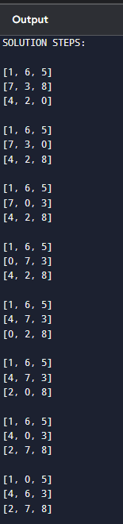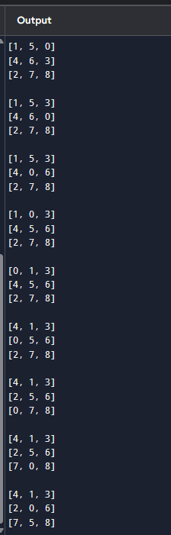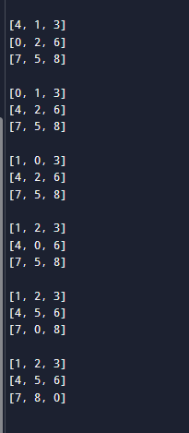

EXPERIMENT- 2: Towers of Hanoi problem

def towers_of_hanoi(n, source, temp, destination):
if n == 1:
print(f"Move disk 1 from {source} to {destination}")
return

towers_of_hanoi(n - 1, source, destination, temp)
print(f"Move disk {n} from {source} to {destination}")
towers_of_hanoi(n - 1, temp, source, destination)

n = 3
towers_of_hanoi(n, 'A', 'B', 'C')

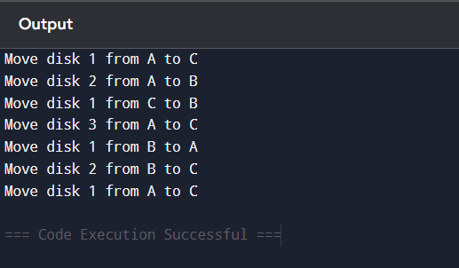

Experiment-3:-Breadth-First Search (BFS)
from collections import deque
graph = {
0: [2, 1, 3],
1: [],
2: [4],
3: [],
4: []
}
def bfs(start):
visited = set()
queue = deque([start])
order = []
while queue:
node = queue.popleft()
if node not in visited:
visited.add(node)
order.append(node)
for neighbor in graph[node]:
queue.append(neighbor)
return order
result = bfs(0)
print("BFS Traversal Order:", result)
Output:
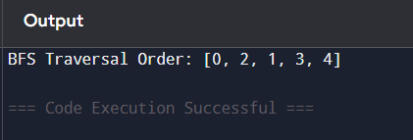
Experiment-4: Monkey and Banana problem
class MonkeyBanana:
def __init__(self):
self.monkey_position = "door"
self.box_position = "window"
self.banana_position = "center"
self.monkey_on_box = False
self.has_banana = False
def move_monkey(self, location):
print(f"Monkey moves from {self.monkey_position} to {location}.")
self.monkey_position = location
def push_box(self, location):
if self.monkey_position == self.box_position:
print(f"Monkey pushes box from {self.box_position} to {location}.")
self.box_position = location
else:
print("Monkey must be at the box to push it!")
def climb_box(self):
if self.monkey_position == self.box_position:
print("Monkey climbs onto the box.")
self.monkey_on_box = True
else:
print("Monkey must move to the box first.")
def grab_banana(self):
if self.monkey_on_box and self.box_position == self.banana_position:
print("Monkey grabs the banana! 🍌")
self.has_banana = True
else:
print("Monkey cannot reach the banana.")
def solve(self):
print("\n--- Monkey and Banana Problem Simulation ---\n")
self.move_monkey("window")
self.push_box("center")
self.move_monkey("center")
self.climb_box()
self.grab_banana()
print("\nFinal Status:")
print(f"Monkey has banana: {self.has_banana}")
problem = MonkeyBanana()
problem.solve()
Output:
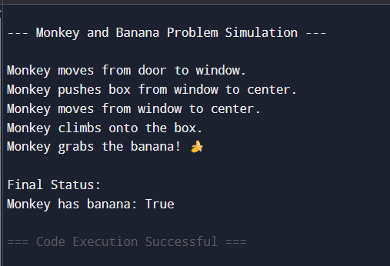

Experiment-5: place eight queens on an 8 x 8
def is_safe(board, row, col):
for i in range(row):
if board[i] == col or abs(board[i] - col) == abs(i - row):
return False
return True

def solve(board, row):
if row == 8:
return True
for col in range(8):
if is_safe(board, row, col):
board[row] = col
if solve(board, row + 1):
return True
return False

def print_board(board):
for r in range(8):
print(" ".join("Q" if board[r] == c else "." for c in range(8)))

board = [-1] * 8
solve(board, 0)
print_board(board)
Output:
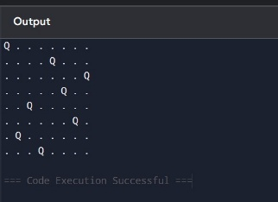
Experiment- 6: Depth-First Search (DFS)
def dfs(graph, start, visited=None):
if visited is None:
visited = set()
print(start, end=" ")
visited.add(start)

for neighbour in graph[start]:
if neighbour not in visited:
dfs(graph, neighbour, visited)

# Graph (adjacency list)
graph = {
5: [3, 7],
3: [2, 4],
7: [8],
2: [],
4: [8],
8: []
}

print("DFS Traversal:")
dfs(graph, 5)
Output:
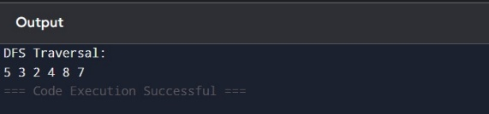

Experiment-7: Water Jug problem
from collections import deque

def solve_water_jug():
visited = set()
queue = deque([(0, 0)]) # (4-gal jug, 3-gal jug)

while queue:
a, b = queue.popleft()

if (a, b) in visited:
continue
visited.add((a, b))

print(a, b) # show steps

if a == 2: # goal: 2 gallons in 4-gallon jug
print("Reached 2 gallons in the 4-gallon jug!")
return

# Possible actions
moves = [
(4, b), # fill 4-gal
(a, 3), # fill 3-gal
(0, b), # empty 4-gal
(a, 0), # empty 3-gal
(a - min(a, 3 - b), b + min(a, 3 - b)), # pour 4 → 3
(a + min(b, 4 - a), b - min(b, 4 - a)) # pour 3 → 4
]

for m in moves:
if m not in visited:
queue.append(m)

solve_water_jug()
Output:
